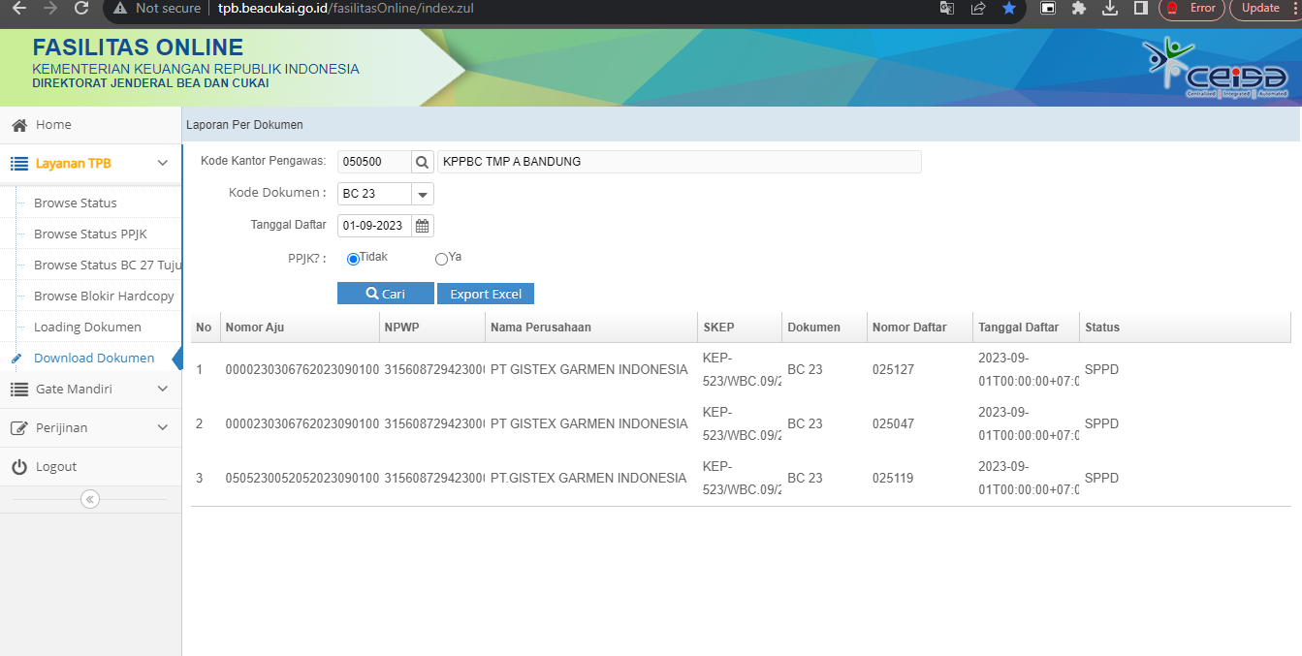

[tpb bea cukai - Search](https://customer.beacukai.go.id/)

https://customer.beacukai.go.id/

